PROGRAM:
import cv2
import numpy as np

img = cv2.imread("rotation_image.png")

if img is None:
print("Image not found! Check the image name.")
else:
gray = cv2.cvtColor(img, cv2.COLOR_BGR2GRAY)
gray = np.float32(gray)

corners = cv2.cornerHarris(gray, 2, 3, 0.04)

img[corners > 0.01 * corners.max()] = [0, 0, 255]

cv2.imshow("Harris Corner Detection", img)

cv2.imwrite("harris_corners.png", img)

cv2.waitKey(0)
cv2.destroyAllWindows()

print("Harris corner detection completed successfully!")
OUTPUT:
The input image is displayed with detected corners marked in red. The processed image is saved as harris_corners.png.
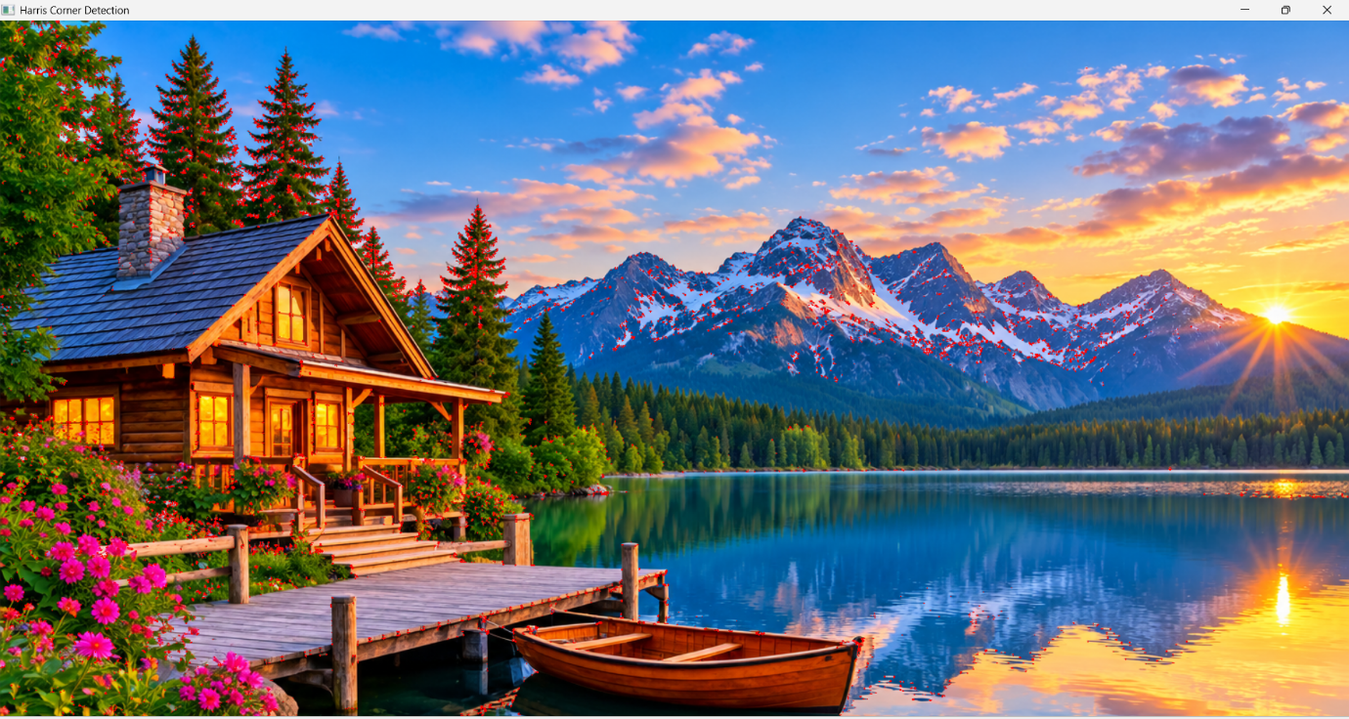

RESULT:
Thus, the image was successfully read using Python, and corners were detected using the Harris Corner Detection function in OpenCV.

